|  |
| --- |
| **Dementia Education Matrix** |
| The Dementia Education Matrix details dementia and dementia-related education available for various staff groups through TURAS or face to face* delivery internally for NHS Golden Jubilee University National Hospital staff.  A training programme will follow to support staff in the management of Delirium – priorities and content will be developed in conjunction with GJUNH Delirium Group. |
| * Dementia educational requirements should be decided at a local ward/department/team level – this might vary from area to area depending on the specialism (see page 2 for details on specific dementia knowledge and skills needed by staff). * Module / programme selection will be dependent on specific job role and care setting. * Individual learning needs should be discussed and identified at an appraisal and a personal development plan agreed.   (* Certain courses will not be available until 2024 - please contact Lead Dementia Nurse to discuss).  Managers of wards / departments / teams should identify core and desirable modules / programmes (see page 2) to be completed by all healthcare professionals working in their care setting and documented on the template on page 3. Then it should be approved by the relevant Clinical Nurse Manager and/or Head of Nursing. You can find the pathway to the Dementia Learning resources on TURAS on pages 4 – 6 of this document. |

|  |
| --- |
| **Promoting Excellence Knowledge and Skills Framework Levels** |
| **Each level sets the specific knowledge and skills** specific staff need based on their role rather than their position in the organisation, or their profession.  The **Dementia Informed Practice Level** provides the baseline knowledge and skills required by ***all*** staff working in health and social care settings, including in a person's own home.  The **Dementia Skilled Practice Level** describes the knowledge and skills required by all staff who have **direct and/or substantial contact** with people with dementia, their families and carers.  The **Enhanced Dementia Practice Level** outlines the knowledge and skills required by health and social care staff who have more **regular and intense contact with people with dementia**, provide specific interventions, and/or direct and co-ordinate care and services for people with dementia.  The **Expertise in Dementia Practice Level** outlines the knowledge and skills required for health and social care staff who, **through their role and practice setting, play an expert specialist role** in the care, treatment and support of people with dementia.  The knowledge and skills outlined at each level follow on from each other. For example**, staff who operate at the Dementia Enhanced Practice Level would also have the knowledge and skills, attitudes and behaviours described at the levels before.** |

**\*Please contact Lead Dementia Nurse to discuss and arrange face to face training opportunities.**

|  |  |  |  |  |  |  |  |
| --- | --- | --- | --- | --- | --- | --- | --- |
| **Level of promoting excellence** | **Educational module/programme** | **Mode** | **Staff group learning resource is aimed at** | | | | |
| **Nursing** | **AHP** | **Medical** | **NA / HCSW** | **Non-clinical** |
| **Informed** | **NES Informed about Dementia - Informed Practice Videos** | TURAS | X | X | X | X | X |
| **Dementia Friends \*** | Face to face |  |  |  | X | X |
| **Skilled** | **NES Supporting People with Dementia in Acute Care** | TURAS | X | X | X | X | X |
| **NES Dementia Skilled Improving Practice** | TURAS | X | X | X | X | X |
| **NES Introduction to Delirium** | TURAS | X | X | X | X | X |
| **NES What is Stress and Distress in Dementia** | TURAS | X | X | X | X | X |
| **NES Frontotemporal Dementia** | TURAS | X | X | X | X | X |
| **NES Dementia Skilled \*** | Face to face | X | X | X | X |  |
| **NES Essentials of Psychological Care in Dementia (Stress and Distress) \*** | Face to face | X | X | X | X |  |
| **Think Capacity Think Consent (AWI)** | TURAS | X | X | X | X |  |
| **Enhanced** | **NES Delirium: Prevention, Management and Support** | TURAS | X | X | X | X |  |
| **NES: Promoting Psychological Wellbeing for People with Dementia and their Carers** | TURAS | X | X | X | X |  |
| **NES: Promoting Excellence in Supporting People through a Diagnosis of Dementia** | TURAS | X | X | X | X |  |
| **NES: ACE-III Trainer** | TURAS | X | X | X |  |  |
| **Dementia Champions Programme** (National Programme by application)  *Target Audience: Nurses and AHPs working in Acute and Community Hospitals*  *( availability of this course to be confirmed)* | Face to face | X | X |  |  |  |
| **Expertise** | **Dementia Specialist Improvement Leads* (DSIL)** (National Programme by application)  *Target Audience: Nurses and AHPs working in mental health, social care and care home settings* | Face to face | X | X |  |  |  |

|  |  |
| --- | --- |
| **Other NES Training and Workshops** | |
| **Log in to *Once for Dementia Learning Site* on TURAS Learn for more details on content and dates of sessions** [**https://learn.nes.nhs.scot/24388/once-for-nes-dementia**](https://learn.nes.nhs.scot/24388/once-for-nes-dementia) | |
| **Skilled Level** | Palliative and End of Life Care in Dementia for Frontline Staff |
| **Enhanced Level** | Cognitive Stimulation Therapy (CST) Capacity Building Training Workshop |
| **Enhanced Level** | Essentials in Psychological Care – Dementia: Training for Trainers |
| **Enhanced Level** | Essentials in Psychological Care – Dementia: Coaching Workshop |
| **Enhanced Level** | Psychological Interventions in Response to Stress and Distress in Dementia: Training for Trainers |
| **Enhanced Level** | Psychological Interventions in Response to Stress and Distress in Dementia: Coaching Workshop |
| **Enhanced Level** | Cognitive Rehabilitation in Dementia Workshop |
| **Enhanced Level** | Dementia Masterclasses – Various topics |

|  |  |  |  |
| --- | --- | --- | --- |
| **Core and desirable Dementia modules / programmes template** | | | |
| **To be completed by each Ward / Department / Team Manager** | | | |
| **Division:** Golden Jubilee National Waiting List Hospital | | | |
| **Hospital / site:**  NHS Golden Jubilee University National Hospital | | | |
| **Ward / Dept. / Team:** | | | |
| **Name:** | | **Job title:** | |
| **Staff Group:**  E.g. nursing, medical, NA/HCSW, OT, Physio, admin & clerical facilities / support staff, estates, etc. | **Core educational modules / programmes** | | **Desirable educational modules / programmes (if required)** |
| **Registered Nurse/ Allied Health Professional** | * NES Informed about Dementia (Practice videos) * NES Supporting People with Dementia in Acute Care * NES Delirium: Prevention, Management and Support * NES What is Stress and Distress in Dementia? * NES Think Capacity, Think Consent | | * NES Essentials of Psychological Care in Dementia (Stress and Distress) ** * National Dementia Champion Programme (to be confirmed) |
| **Nursing Auxiliary / Healthcare Support Worker** | * NES Informed about Dementia (Practice videos) * NES Supporting People with Dementia in Acute Care * NES Introduction to Delirium * NES What is Stress and Distress in Dementia? | | * NES Delirium: Prevention, Management and Support * NES Think Capacity, Think Consent * NES Essentials of Psychological Care in Dementia (Stress and Distress) ** |
| **Activity Co-ordinator** | * NES Informed about Dementia (Practice videos) * NES Supporting People with Dementia in Acute Care * NES Introduction to Delirium * NES What is Stress and Distress in Dementia? | | * NES Delirium: Prevention, Management and Support * NES Think Capacity, Think Consent |
| **Ward Clerk** | * NES Informed about Dementia (Practice videos) | | * Dementia Friends ** |

|  |  |  |
| --- | --- | --- |
| **Approved by appropriate manager** | **Name:** | **Signature:** |
| **Title:** | |

**Finding Dementia Learning Resources on TURAS**

Step 1 - Log in to TURAS site

Step 2 - Select ‘Learn’ from the application dashboard

Or click on this link: [Home | Turas | Learn (nhs.scot)](https://learn.nes.nhs.scot/)

Step 3 - Type ‘dementia learning site’ in the search box and press enter

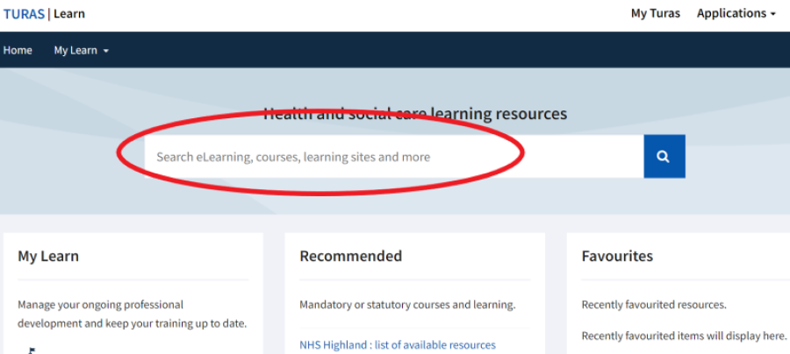

Step 4 – Select ‘Once for NES: Dementia from the search results

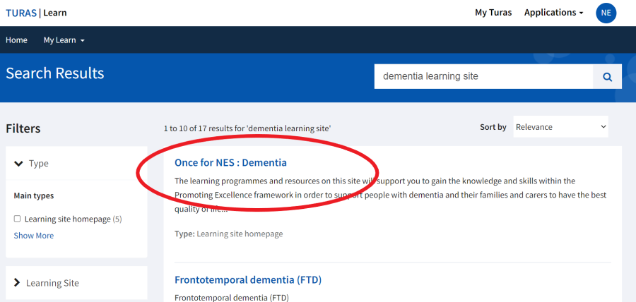

Step 5 – Select the learning resource you want from the menu on the left-hand side

(see list of levels / resources below)

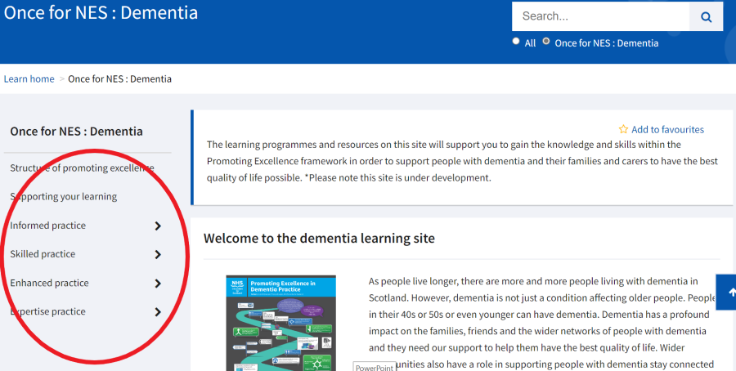

Learning resources are stored under the four different levels of the Promoting Excellence Framework:

**Informed practice**

**(Learning resources)**

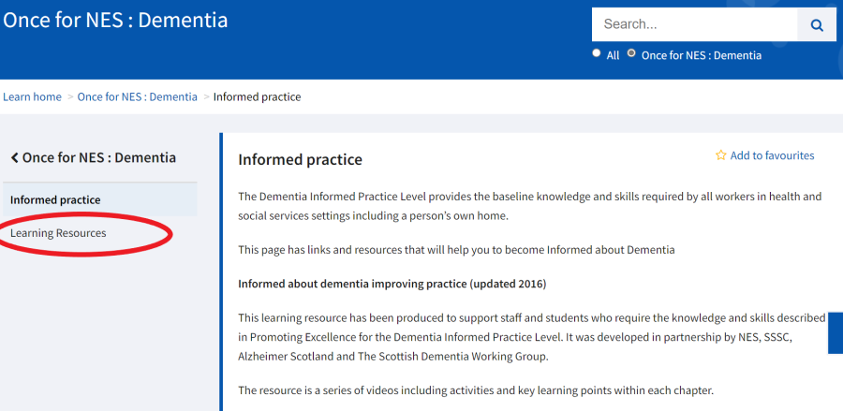

**Skilled practice**

**(Frontotemporal dementia [FTD] / Learning resources / Training workshops)**

**Enhanced practice**

**(Learning resources / Training and workshops)**

**Expertise practice**

**(Learning resources / Training and workshops)**

|  |  |
| --- | --- |
| With thanks to NHS Fife for the original guidance, upon which this document has been based – the core document is used across all NHS Boards via Alzheimer Scotland Dementia Consultant Group. | |
| This version: September 2023 | Con Gillespie Lead Dementia Nurse (GJNUH) |